Practical 2: Does changing the mass of a pendulum affect a pendulum’s period?

Background information (What do you need to know before you start your investigation? Use the internet to help you with your answers)
General introduction to topic
Pendulums have fascinated scientists and inventors for centuries, from powering ancient clocks to being used in modern physics experiments. The ancient Chinese used the pendulum to try and help predict earthquakes.

Galileo Galilei was the first European to really study pendulums and he discovered that their regularity could be used for keeping time, leading to the first clocks. This understanding has led to developments in timekeeping, seismology (to detect earthquakes), and even in amusement park rides. By studying pendulum motion, we can gain a deeper insight into the motion, energy transfer, and gravity, which are essential concepts in physics and engineering.
Rationale for this field of work
The variables
A pendulum is a mass (called a bob) attached to a rod, chain or rope that swings back and forth repeatedly. The period of a pendulum is the time it takes to complete one entire swing, back and forth. Each period is measured in seconds. Other factors such as the length of the string and angle of release should remain constant to ensure a fair test.
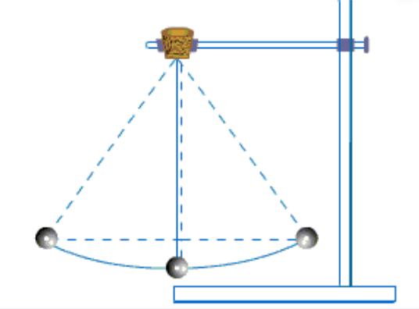
Background
research; true value

Galileo Galilei’s studies on the pendulum in 1602 allowed for scientific advancements in instruments used for measuring time and how explorers found their position on Earth.
The expected true value of a pendulum’s period for a mass that is 200g is 1.1 seconds.
Purpose of investigation

This investigation will examine the influence on the mass of the bob on the pendulum’s motion and hence its period.

COMPLETE BEFORE THE PRACTICAL:

Question 1
- Who first studied pendulums and for what purpose?

_________________________________________________________________________________

- Further study of pendulums led to the development of what modern device?
_________________________________________________________________________________

- How do we measure the period of a pendulum?

_________________________________________________________________________________

- Label the parts of the pendulum (bob, rod, chain) on the diagram on the previous page.

QUESTIONING AND PREDICTING

Question 2
Identify the following variables of the investigation:
  - Independent variable: (IV) The independent variable is the factor deliberately changed by the scientists during the different trials of the experiment.

_________________________________________________________________________________

  - Dependent variable: (DV) the variable that is being measured in an experiment; it changes as the independent variable changes.

_________________________________________________________________________________

  - Controlled Variables (CV): Variables that must stay the same to ensure a fair test is conducted

- ___________________________________________________________________________

- ___________________________________________________________________________

- ___________________________________________________________________________

Question 3
Using the research question and background information provided to you, write an aim for the experiment. (What is being investigated in this investigation? A statement that has the IV and DV)

_________________________________________________________________________________

_________________________________________________________________________________

_________________________________________________________________________________
Question 4
Using the research question and background information provided to you, write a hypothesis for the experiment that included a ‘cause-and-effect’ relationship between the IV and DV.
_________________________________________________________________________________

_________________________________________________________________________________

_________________________________________________________________________________

PLANNING AND CONDUCTING

Equipment:
(Equipment list should include quantities of equipment and chemicals required. Volume and concentration of solutions required should be included. Mass of solids required should be included.)

- 1 x Retort stand
- 1 x Retort clamp
- 1 x 30 cm length of string
- 1 x Ruler
- 1 x Protractor
- 1 x Stopwatch
- 1 x Scissors
- Plasticine to use as a variable weight
- Sticky tape
- Electronic balance

Method:
(Be sure to include how your IV changes, what you are using to measure your DV, and repeat trials to improve accuracy. Method should include a numbered list of instructions that can be followed by someone else.)
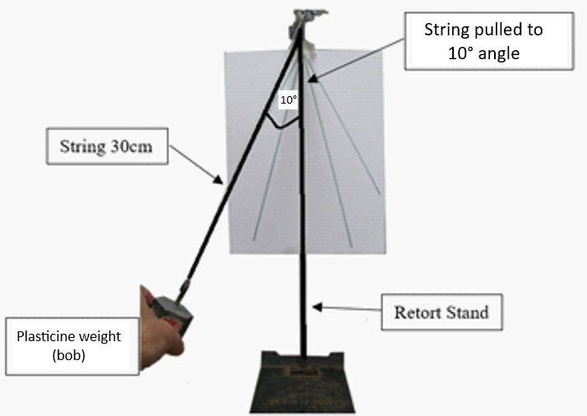
- Set up the pendulum frame as shown in the diagram to the right.
- Adjust the length of the pendulum string to 30cm. Measure the weight of your plasticine mass and record it in the table
- Pull the bob (keeping the string tight) so that the string has been pulled back 10°
- Start the stopwatch when the pendulum has been released.
- Count 10 full periods and stop the stopwatch.
- Divide the time by 10 to calculate ONE period
- Repeat the trial 3 times then calculate the average in the last column of your table.
- Repeat steps 2-7 with increasing masses of plasticine (recording the mass and time in the results table).

SAFETY PRECAUTIONS:
Question 5

Identify the controlled measure for the safety hazard in the table below.

Identify Hazard  (equipment or chemical) | Assess Risk  (possible harm the hazard could cause) | Control Measure  (personal protective equipment to be worn or actions to take)
Scissors | Could cut yourself
Retort stand and clamp | Clamp could pinch fingers

ETHICAL CONSIDERATIONS:

Question 6
Were there any ethical issues that needed to be considered when preparing and conducting this experiment? If so, identify one ethical consideration in the table below.

Identify Ethical Consideration | Control Measure  (actions to take)

RECORDING AND PROCESSING

Question 7
Construct a results table for the experiment in the space below. Record all of your data/measurement in this table. (You must include the independent variable, dependent variable, units of measurement and title).

Average = Trial 1 + Trial 2 + Trial 3
3

Question 8
Using the graph paper below, draw an appropriate line graph for the results of the experiment.
(You should use the majority of the graph paper, a pencil and a ruler).

Tips:
- Put the independent variable on the horizontal axis and the dependent variable on the vertical axis.
- Write a title that has the independent variable and the dependent variable
- Make sure to include labels and units for both axes
- Use an appropriate scale interval on both axes

TITLE: _____________________________________________________________________________


ANALYZING AND EVALUATING

Question 9
Identify trends, pattern or relationship in the experiment. You must include a statement about the IV, DV and use data from your table or graph to support your answer
___________________________________________________________________________________

___________________________________________________________________________________

___________________________________________________________________________________

___________________________________________________________________________________

___________________________________________________________________________________

Question 10
Do the results support the claim that changing the mass of a pendulum affects a pendulum’s period?

___________________________________________________________________________________

___________________________________________________________________________________

Question 11
Accuracy of data is determined by how close the recorded practical values are to the true value.

The true value is the value that you should be obtaining, as suggested by current research and theory.

Using the true value outlined in the background information, describe if your data for the given investigation could be considered high accuracy or not.

___________________________________________________________________________________

___________________________________________________________________________________

___________________________________________________________________________________

___________________________________________________________________________________

Question 12
Errors are small changes to measurements that cannot be avoided even with care. The four main sources of error are instrument error, parallax error, reading error, personal and zero error.

Identify where these errors may have occurred throughout your experiment.

Type of Error | Error occurring in the experiment. | How could this possibly alter the  quality of data collected?
Instrument Error | Calibration of the ruler
Parallax Error | Reading the protractor at the incorrect angle
Reading Error | The stopwatch might not be stopped exactly after 10 swings.
Zero Error | Stopwatch is not reset to zero between trials | Not present
Personal | Using the incorrect masses

Question 13
Identify two improvements to the method so that any errors (except personal) may be reduced.

- ______________________________________________________________________________

______________________________________________________________________________

- ______________________________________________________________________________

______________________________________________________________________________

COMMUNICATION
Question 14
Write a conclusion for the investigation.
- Restate: the purpose of the investigation [Aim]
e.g. “The aim of the investigation was to …”
- Explain: whether the hypothesis was supported or not [Hypothesis]
e.g. “The hypothesis that [restate hypothesis] was …”
- Results: summarise the results [Trend]
e.g. “The results of the experiment showed that …”
_________________________________________________________________________________

_________________________________________________________________________________

_________________________________________________________________________________

_________________________________________________________________________________

_________________________________________________________________________________

_________________________________________________________________________________

_________________________________________________________________________________

_________________________________________________________________________________

_________________________________________________________________________________

_________________________________________________________________________________

_________________________________________________________________________________

_________________________________________________________________________________

_________________________________________________________________________________

